BPV model schooljaar 2019-2020
Klas BG32
Coach: Jacqueline de Wit

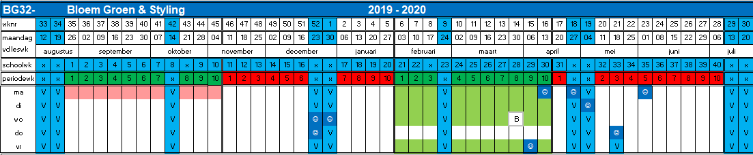

Periode 2:
BPV dag(en) weergegeven in groen
Aantal BPV uren: 296 = 37 dagen

